Cyber Security

Class no 10(Arabi Sir)

19 Oct 2024

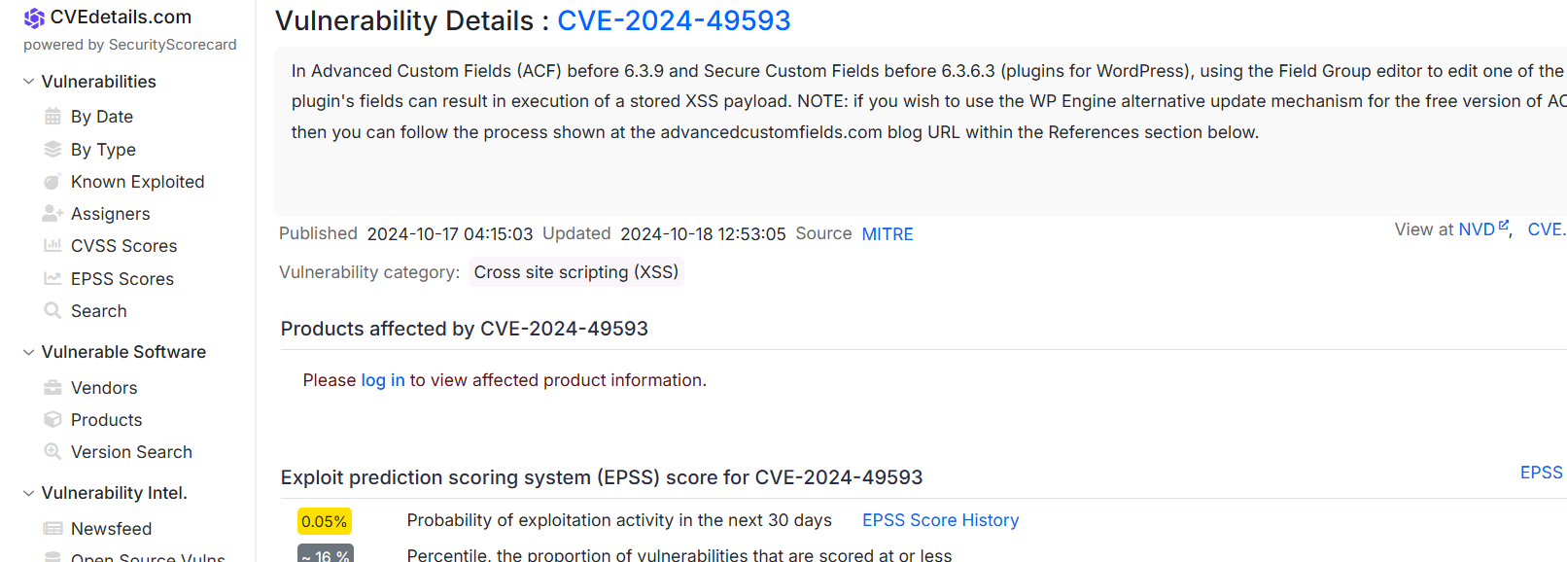

Example: Latest Microsoft Vulnerability Details

**Leakix use for find ip address and all website derived from target web.**

<https://leakix.net/>

<https://leakix.net/graph>

72.249.68.156🡪 juniv.edu

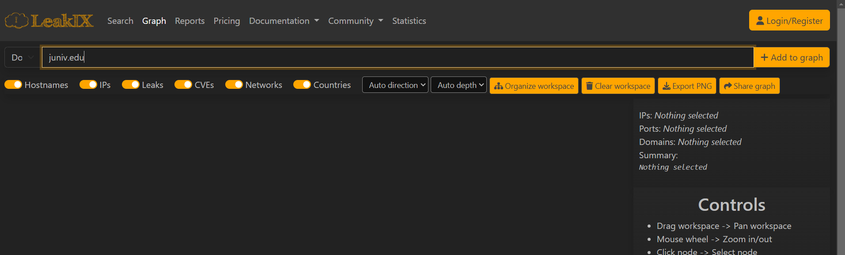

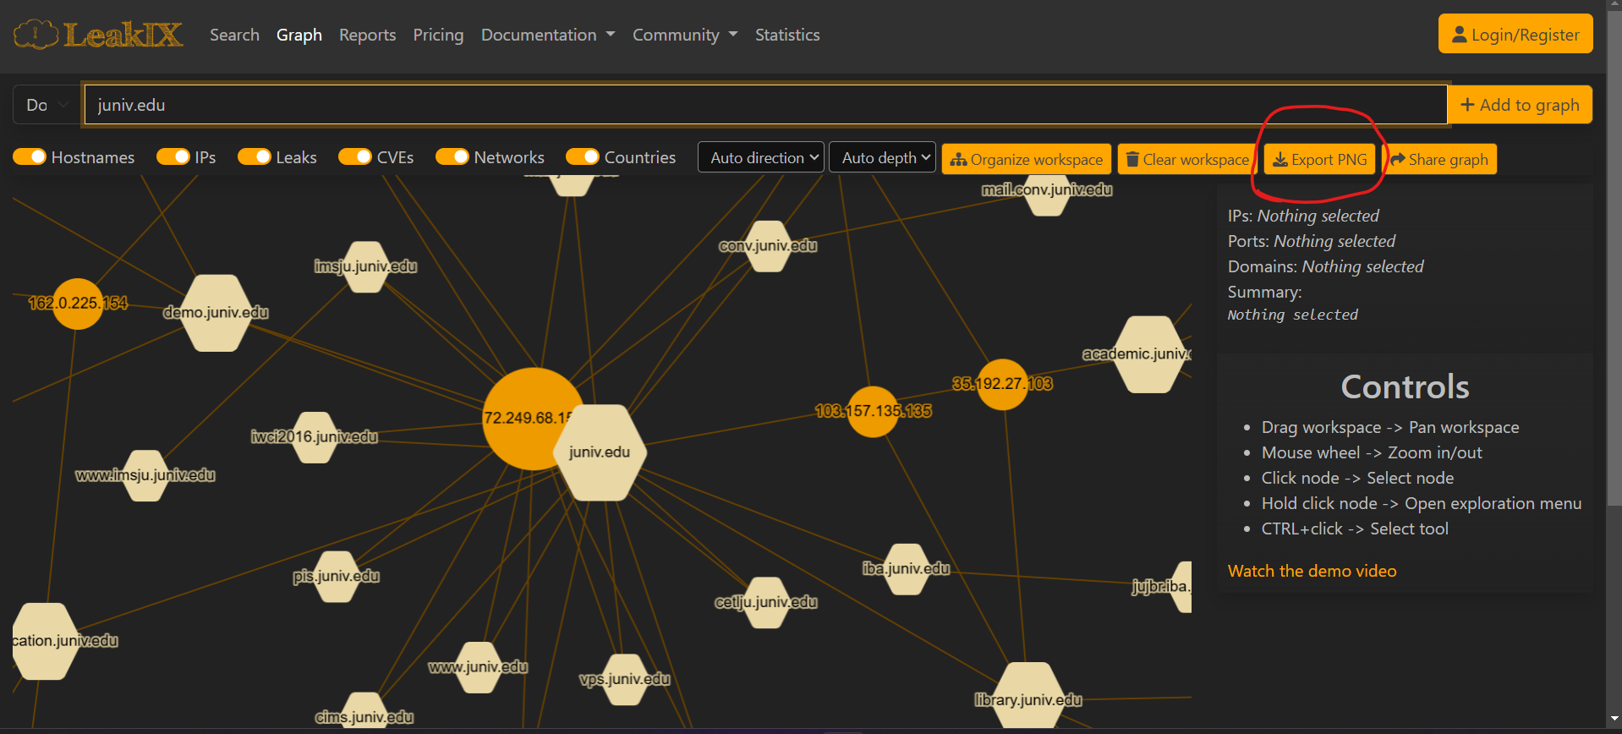

**Threatmap.checkpoint show worldwide live attack**

<https://threatmap.checkpoint.com/>

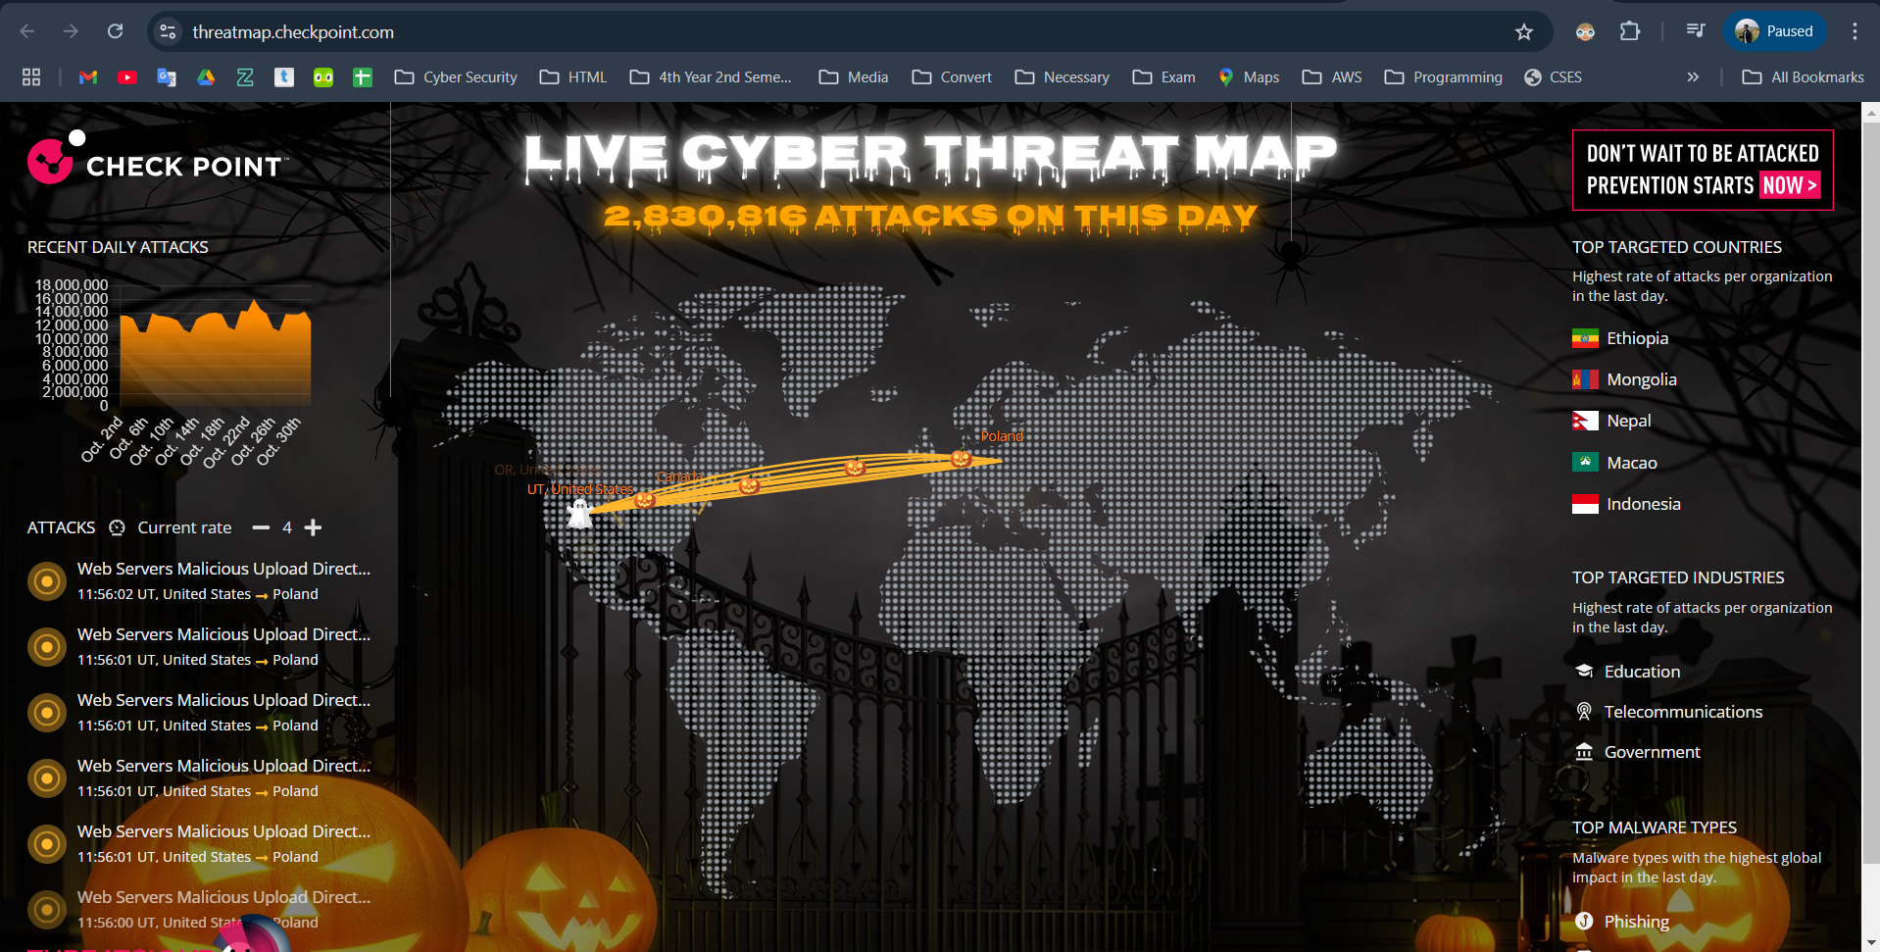

**Whois use for find normal information**

<https://www.whois.com/whois/>

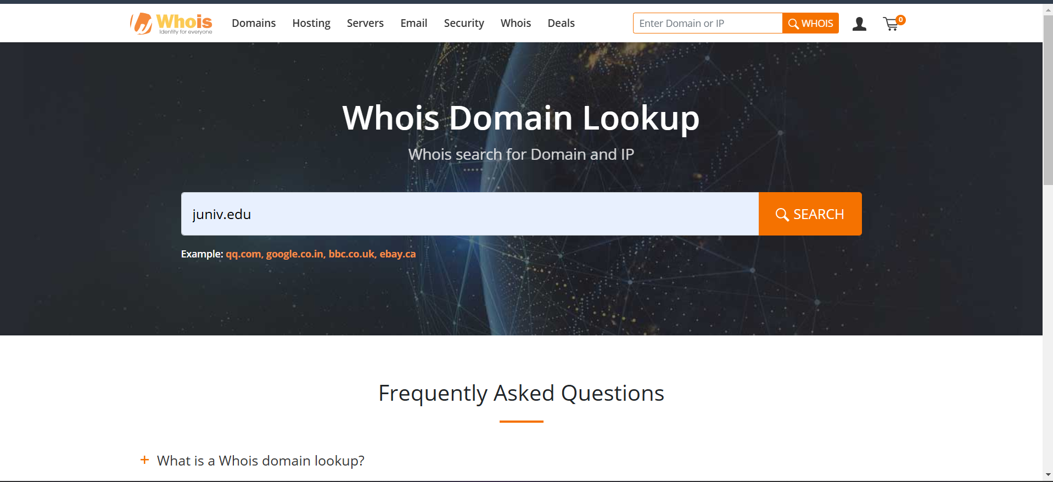

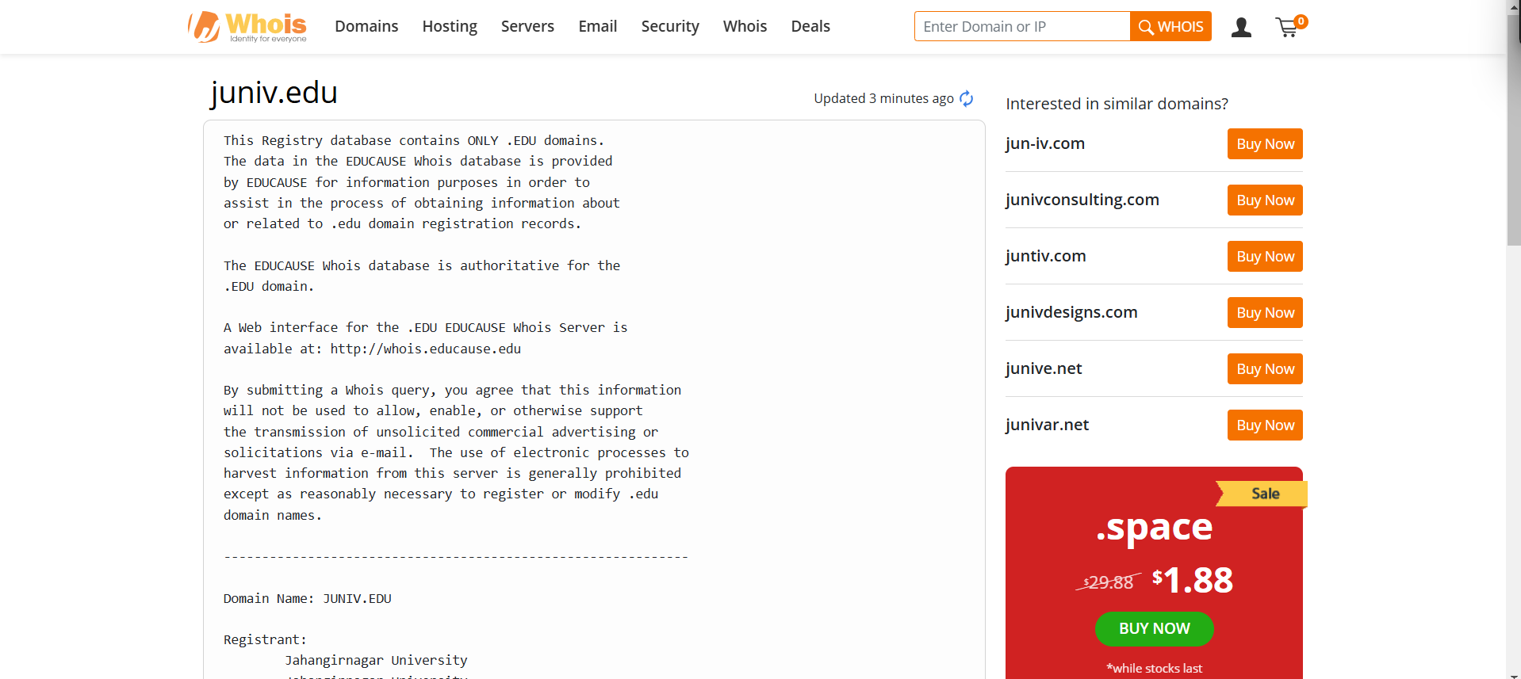

**Who use for find address profile**

<https://who.is/>

72.249.68.156 juniv.edu ip

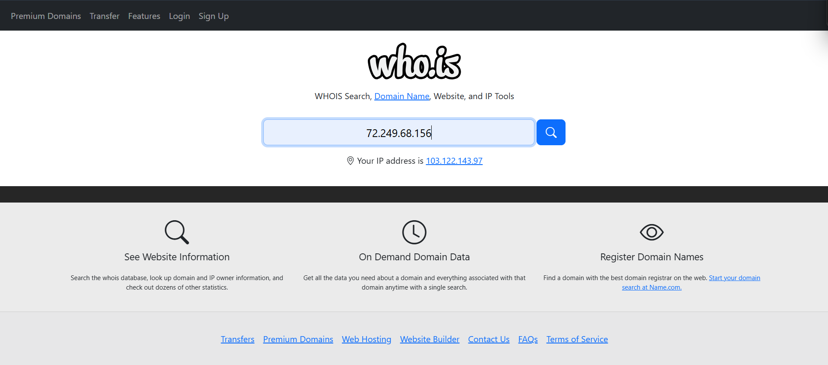

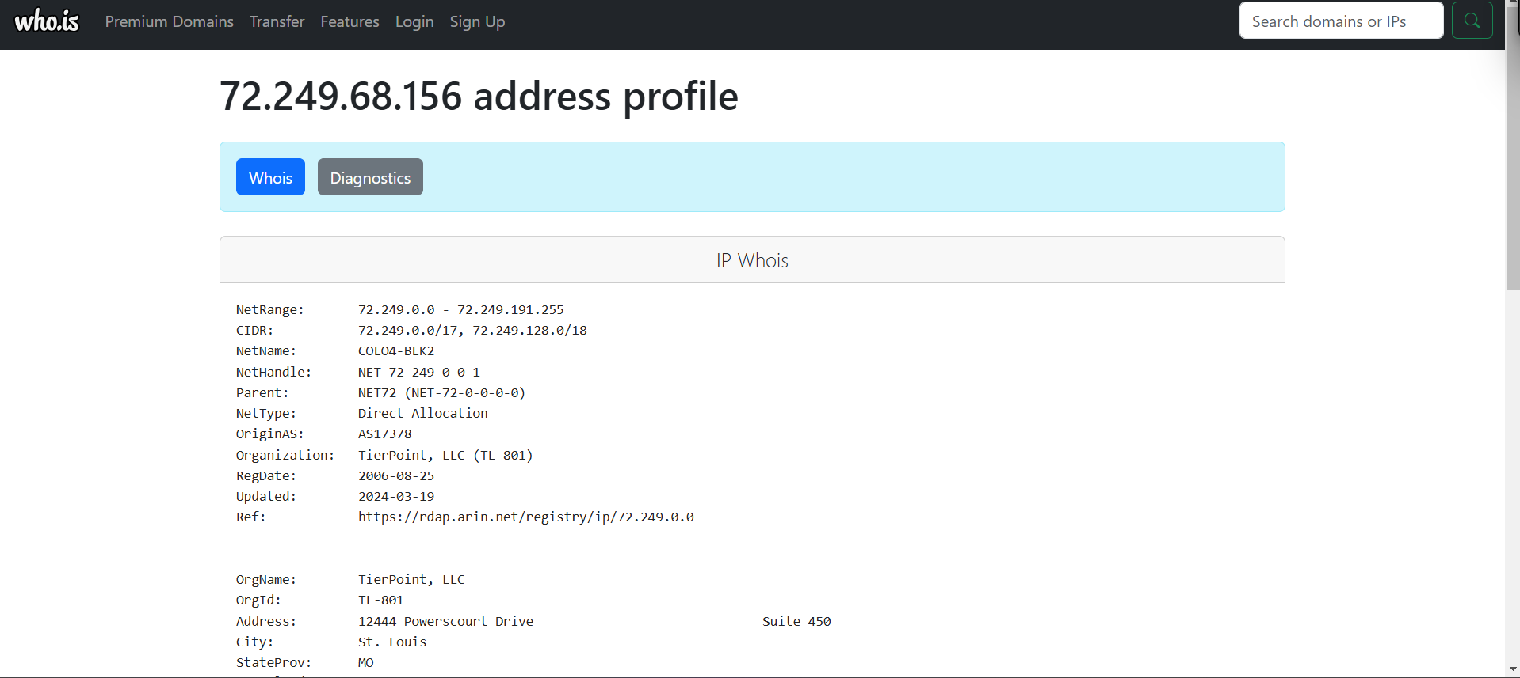

**IPVOID use for find target ip details**

url: <https://www.ipvoid.com/>

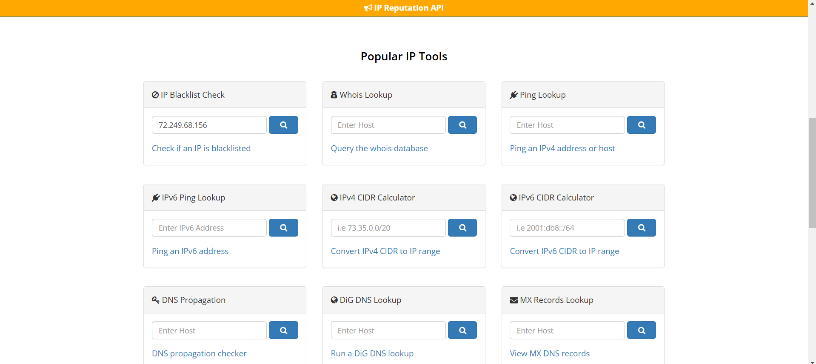

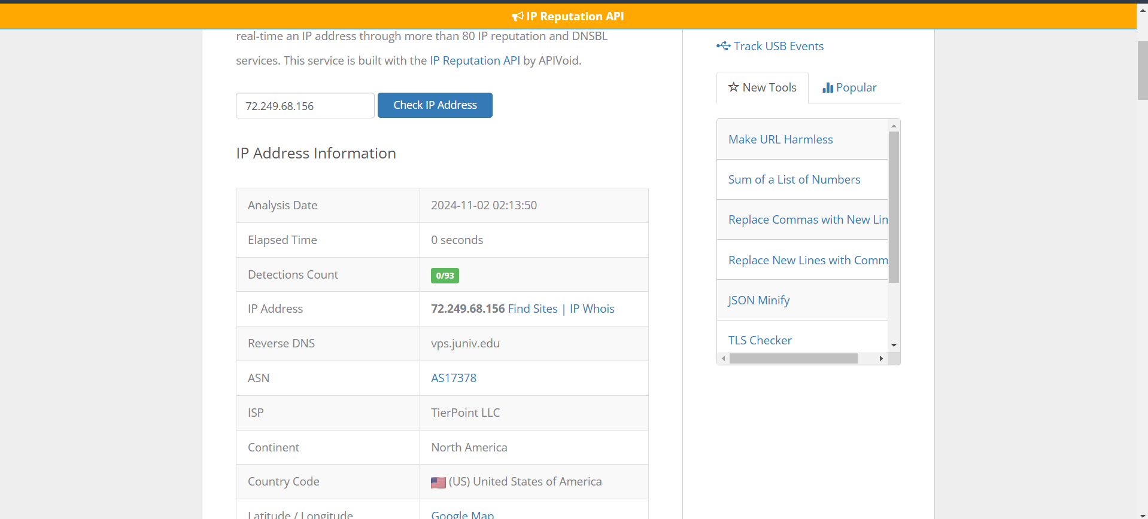

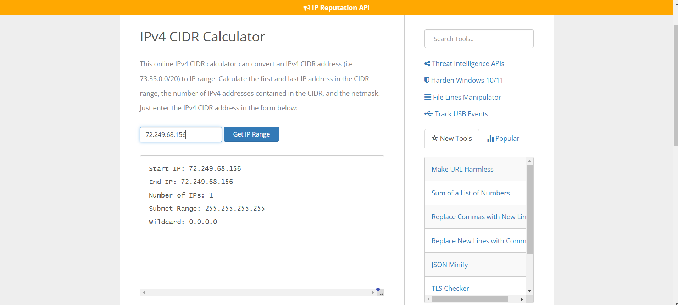



**A mean ip address 🡪 it’s call A record**

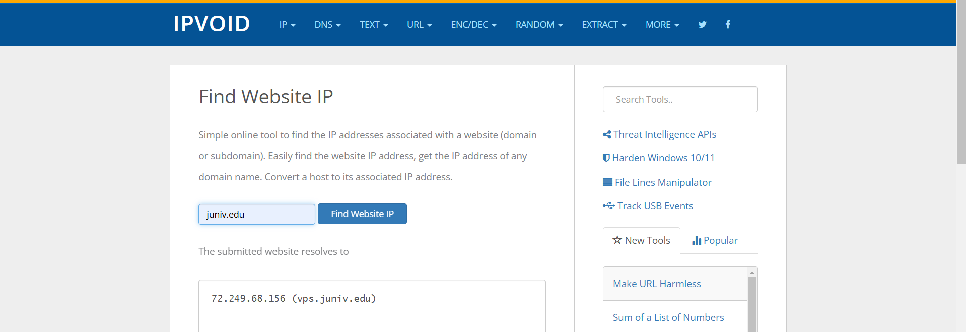

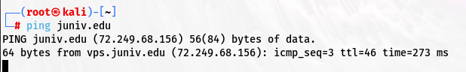

**Nessus/tenable security center🡪 vulnerability scanner**

SLA 🡪 service level argument

url: <https://www.abuseipdb.com/> 🡪 **to send a ip in black list**

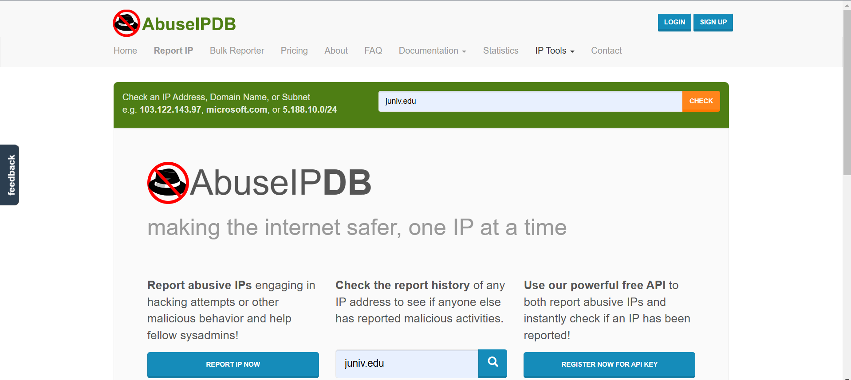

URL: <https://any.run/>

<https://app.any.run/>

<https://any.run/malware-reports/>

<https://app.any.run/submissions/>

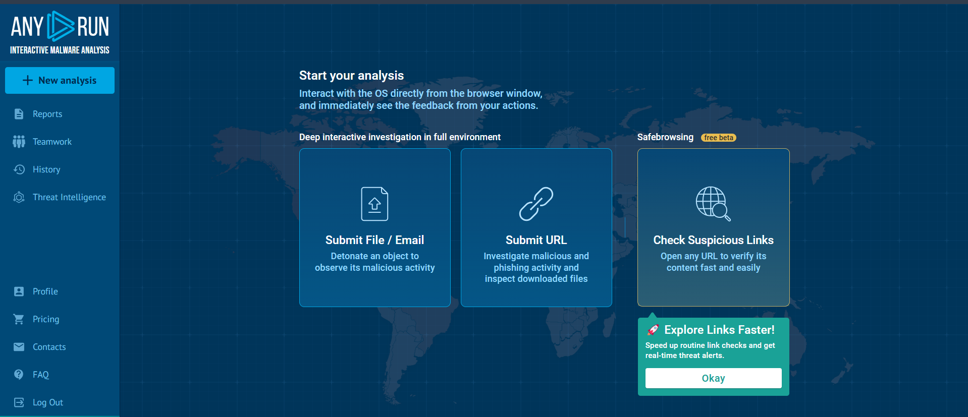

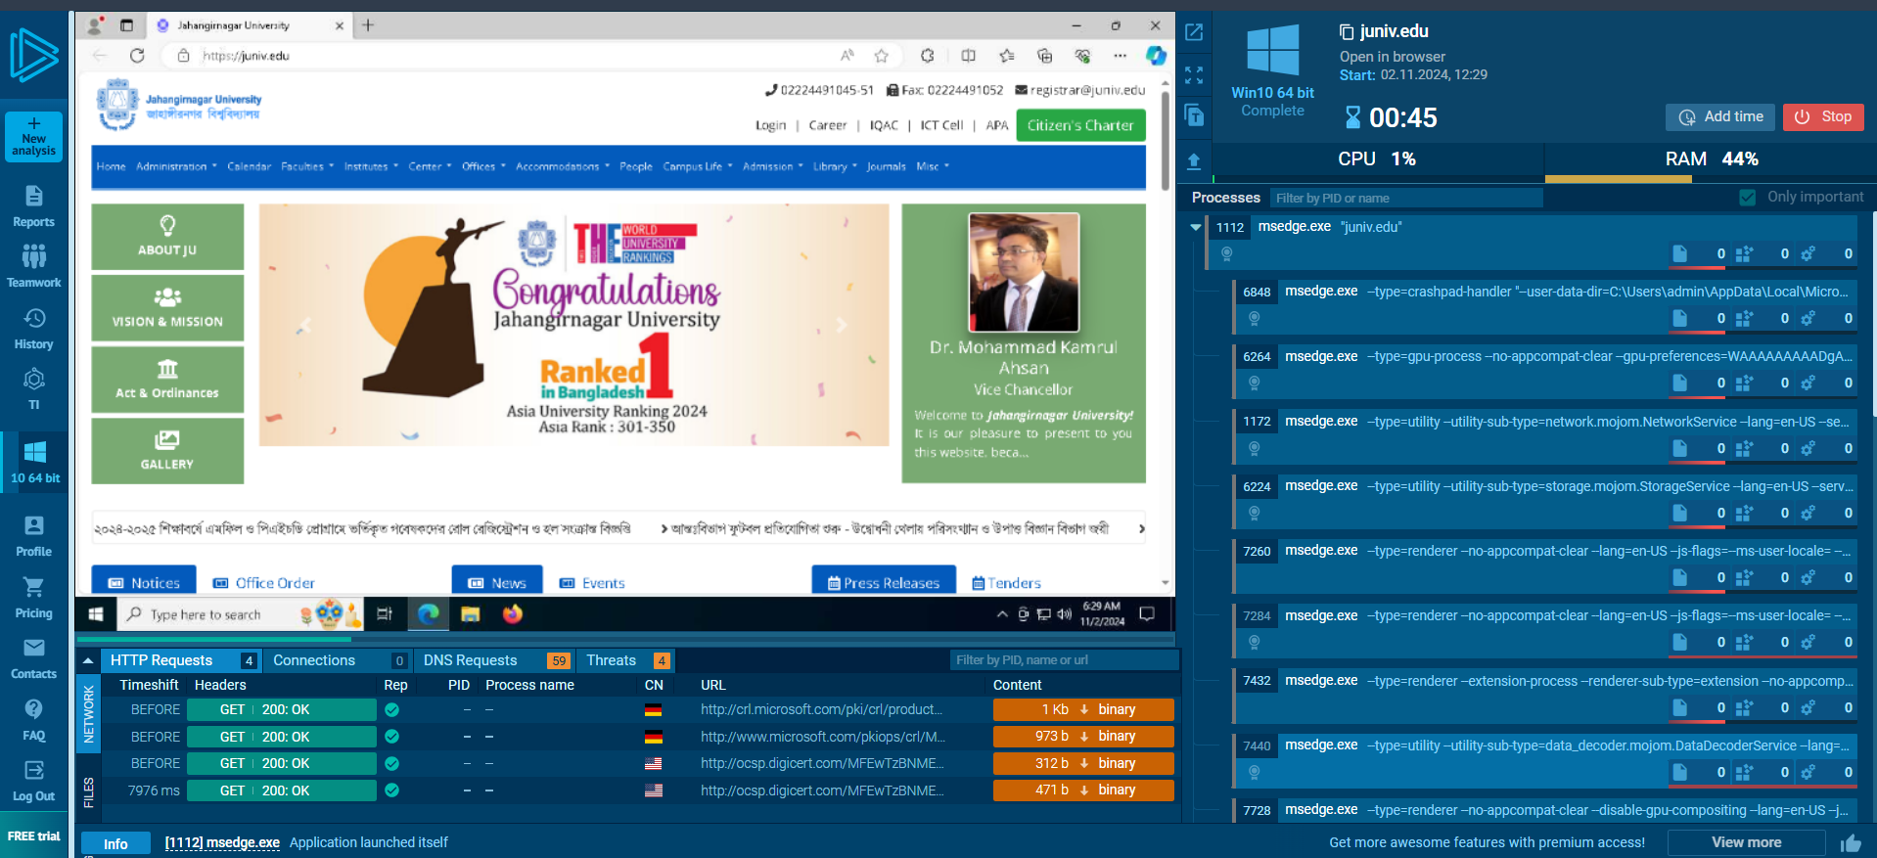

**Report part for find resent vulnerability:**

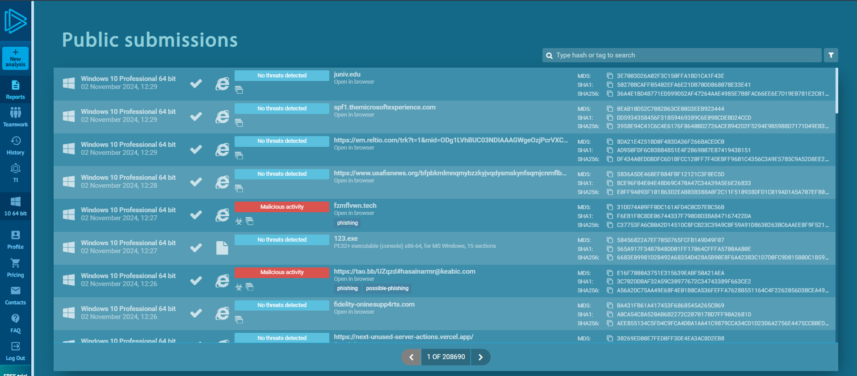

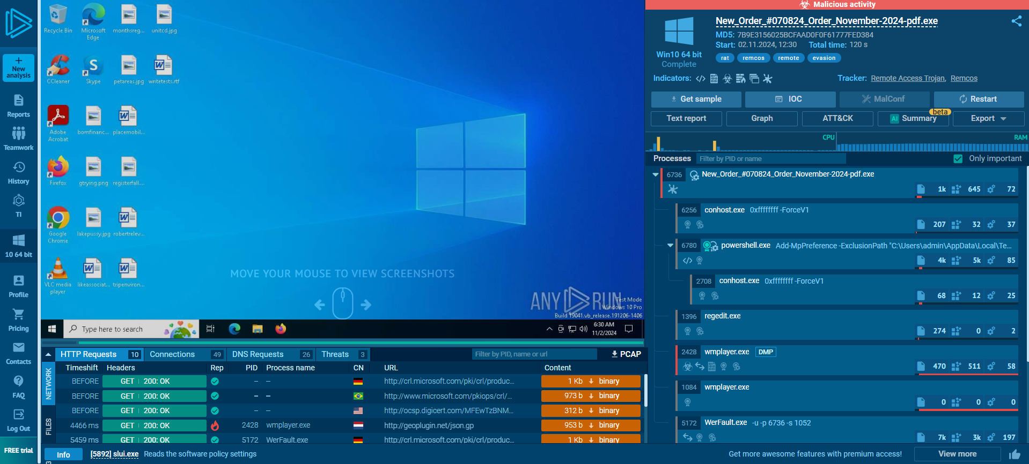

**Graph part to show using all details for every part**

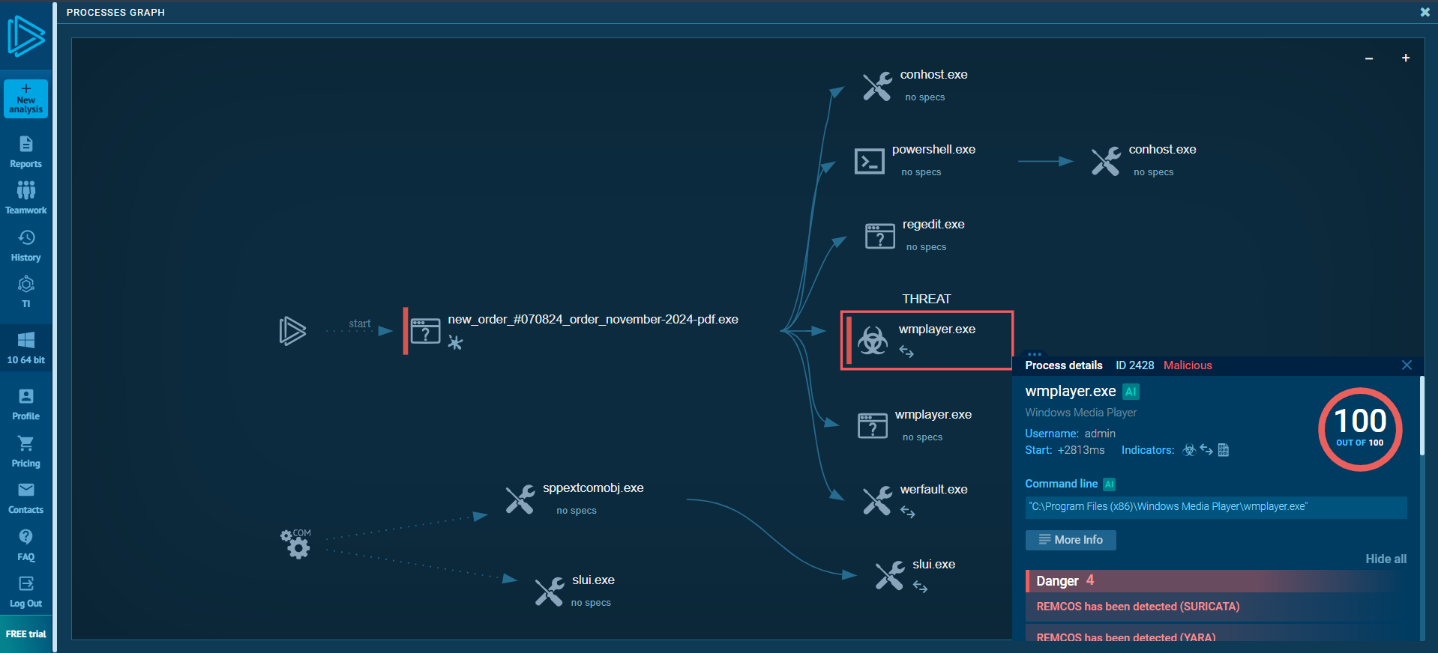

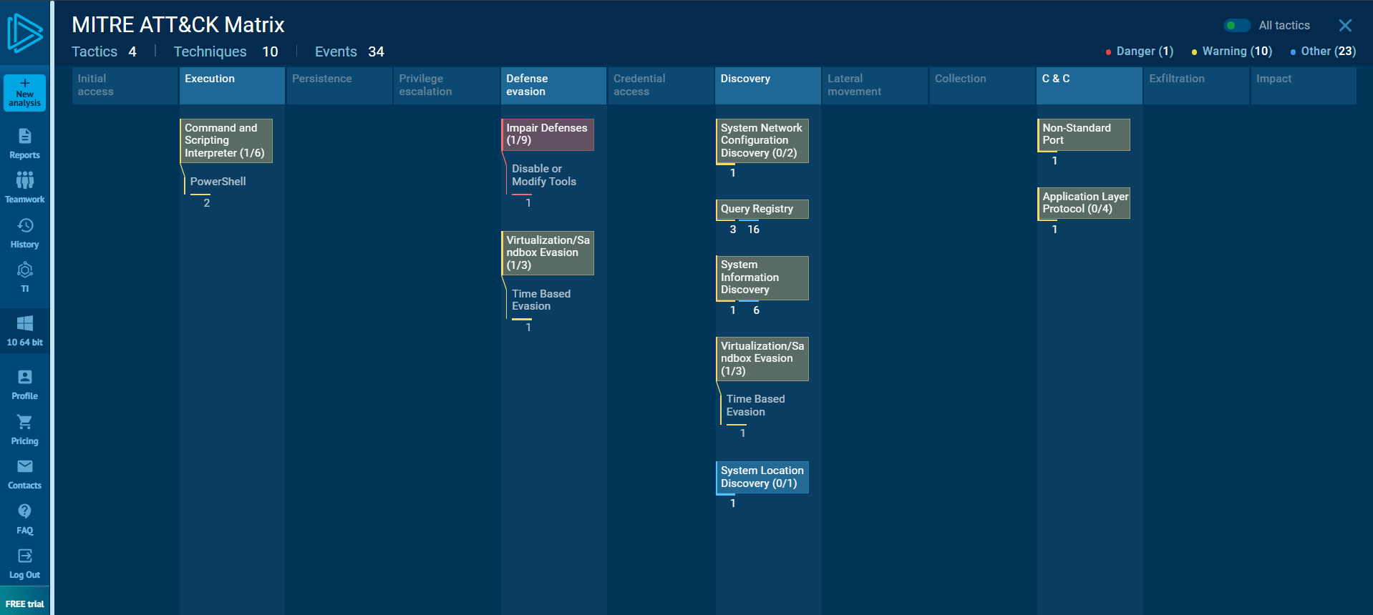

**Information gathering:**

